操作系统实验报告

班号： 10012209 姓名： 梁桐 学号： 2023370018

实验日期： 2024.6.14 实验名称： 设备管理
- 实验目的

任务一：
参考给出的内核源码中的drivers/usb/usb_detect.c文件，编写一个USB探测驱动程序，能够实现以下基本功能：
（1）在插入U盘时能够探测到；
（2）在拔出U盘时能够探测到；
加载、卸载模块并查看模块打印信息。

任务二
编写内核模块测试硬盘的读写速率，加载、卸载模块并查看模块打印信息。
使用用户态下 iozone 工具测试硬盘的读写速率，注意：测试范围需包含与内核模块读写相同的文件大小和块大小(例如都将写入文件大小设置为512M,每次写入数据块大小为1kb)。
对比用户态和内核态下测试的读写速率，并作分析。

- 实验要求
任务一：
正确编写满足功能的源文件，正确编译。
正常加载、卸载内核模块；且内核模块功能满足任务所述。
提交相关源码与运行截图。

任务二：
正确编写满足功能的源文件，正确编译、加载、卸载内核模块；且内核模块功能满足任务所述。
正确安装使用iozone工具测试硬盘读写速率。（可能会比较耗时）
提交相关源码、运行截图与最终分析。
- 实验过程及结果

任务一：
插入U盘前lsusb
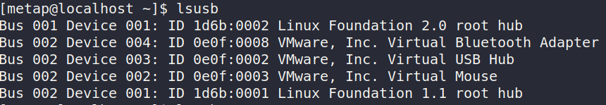
插入U盘后lsusb
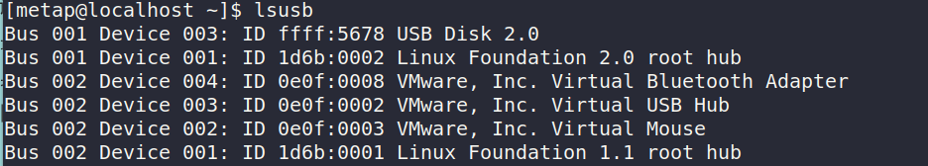
修改源码
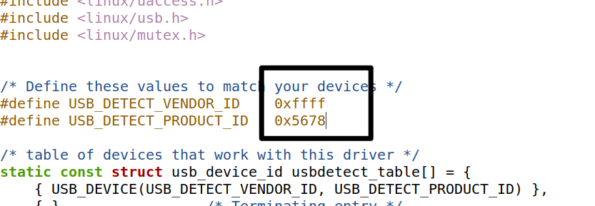
源码：
usb_detect.c:
/*
* USB Detect driver
*
* This driver is based on the 2.6.3 version of drivers/usb/usb-skeleton.c
*/

#include <linux/kernel.h>
#include <linux/errno.h>
#include <linux/slab.h>
#include <linux/module.h>
#include <linux/kref.h>
#include <linux/uaccess.h>
#include <linux/usb.h>
#include <linux/mutex.h>

/* Define these values to match your devices */
#define USB_DETECT_VENDOR_ID 0xffff
#define USB_DETECT_PRODUCT_ID 0x5678

/* table of devices that work with this driver */
static const struct usb_device_id usbdetect_table[] = {
{ USB_DEVICE(USB_DETECT_VENDOR_ID, USB_DETECT_PRODUCT_ID) },
{ } /* Terminating entry */
};
MODULE_DEVICE_TABLE(usb, usbdetect_table);

/* Get a minor range for your devices from the usb maintainer */
#define USB_DETECT_MINOR_BASE 192

#define WRITES_IN_FLIGHT 8
/* arbitrarily chosen */

/* Structure to hold all of our device specific stuff */
struct usb_detect {
struct usb_device *udev; /* the usb device for this device */
struct usb_interface *interface; /* the interface for this device */
struct semaphore limit_sem; /* limiting the number of writes in progress */
struct usb_anchor submitted; /* in case we need to retract our submissions */
struct urb *bulk_in_urb; /* the urb to read data with */
unsigned char *bulk_in_buffer; /* the buffer to receive data */
size_t bulk_in_size; /* the size of the receive buffer */
size_t bulk_in_filled; /* number of bytes in the buffer */
size_t bulk_in_copied; /* already copied to user space */
__u8 bulk_in_endpointAddr; /* the address of the bulk in endpoint */
__u8 bulk_out_endpointAddr; /* the address of the bulk out endpoint */
int errors; /* the last request tanked */
bool ongoing_read; /* a read is going on */
spinlock_t err_lock; /* lock for errors */
struct kref kref;
struct mutex io_mutex; /* synchronize I/O with disconnect */
unsigned long disconnected:1;
wait_queue_head_t bulk_in_wait; /* to wait for an ongoing read */
};
#define to_detect_dev(d) container_of(d, struct usb_detect, kref)

static struct usb_driver usbdetect_driver;

static void usbdetect_delete(struct kref *kref)
{
struct usb_detect *dev = to_detect_dev(kref);

usb_free_urb(dev->bulk_in_urb);
usb_put_intf(dev->interface);
usb_put_dev(dev->udev);
kfree(dev->bulk_in_buffer);
kfree(dev);
}

static const struct file_operations usbdetect_fops = {};

/*
* usb class driver info in order to get a minor number from the usb core,
* and to have the device registered with the driver core
*/
static struct usb_class_driver usbdetect_class = {
.name = "usbdetect%d",
.fops = &usbdetect_fops,
.minor_base = USB_DETECT_MINOR_BASE,
};

static int usbdetect_probe(struct usb_interface *interface,
const struct usb_device_id *id)
{
struct usb_detect *dev;
struct usb_endpoint_descriptor *bulk_in, *bulk_out;
int retval;

/* allocate memory for our device state and initialize it */
dev = kzalloc(sizeof(*dev), GFP_KERNEL);
if (!dev)
return -ENOMEM;

kref_init(&dev->kref);
sema_init(&dev->limit_sem, WRITES_IN_FLIGHT);
mutex_init(&dev->io_mutex);
spin_lock_init(&dev->err_lock);
init_usb_anchor(&dev->submitted);
init_waitqueue_head(&dev->bulk_in_wait);

dev->udev = usb_get_dev(interface_to_usbdev(interface));
dev->interface = usb_get_intf(interface);

/* set up the endpoint information */
/* use only the first bulk-in and bulk-out endpoints */
retval = usb_find_common_endpoints(interface->cur_altsetting,
&bulk_in, &bulk_out, NULL, NULL);
if (retval) {
dev_err(&interface->dev,
"Could not find both bulk-in and bulk-out endpoints\n");
goto error;
}

dev->bulk_in_size = usb_endpoint_maxp(bulk_in);
dev->bulk_in_endpointAddr = bulk_in->bEndpointAddress;
dev->bulk_in_buffer = kmalloc(dev->bulk_in_size, GFP_KERNEL);
if (!dev->bulk_in_buffer) {
retval = -ENOMEM;
goto error;
}
dev->bulk_in_urb = usb_alloc_urb(0, GFP_KERNEL);
if (!dev->bulk_in_urb) {
retval = -ENOMEM;
goto error;
}

dev->bulk_out_endpointAddr = bulk_out->bEndpointAddress;

/* save our data pointer in this interface device */
usb_set_intfdata(interface, dev);

/* we can register the device now, as it is ready */
retval = usb_register_dev(interface, &usbdetect_class);
if (retval) {
/* something prevented us from registering this driver */
dev_err(&interface->dev,
"Not able to get a minor for this device.\n");
usb_set_intfdata(interface, NULL);
goto error;
}

/* let the user know what node this device is now attached to */
dev_info(&interface->dev,
"USB detect device now attached to USBdetect-%d\n",
interface->minor);

/* Print Vendor ID, Product ID, Manufacturer, and Product */
dev_info(&interface->dev,
"Vendor ID: 0x%04X, Product ID: 0x%04X\n",
le16_to_cpu(dev->udev->descriptor.idVendor),
le16_to_cpu(dev->udev->descriptor.idProduct));
dev_info(&interface->dev,
"Manufacturer: %s, Product: %s\n",
dev->udev->manufacturer, dev->udev->product);

return 0;

error:
/* this frees allocated memory */
kref_put(&dev->kref, usbdetect_delete);

return retval;
}

static void usbdetect_disconnect(struct usb_interface *interface)
{
struct usb_detect *dev;

dev = usb_get_intfdata(interface);

dev_info(&interface->dev,
"USB detect device removed from USBdetect-%d\n",
interface->minor);

dev_info(&interface->dev,
"Vendor ID: 0x%04X, Product ID: 0x%04X\n",
le16_to_cpu(dev->udev->descriptor.idVendor),
le16_to_cpu(dev->udev->descriptor.idProduct));

/* Clean up */
usb_set_intfdata(interface, NULL);
usb_deregister_dev(interface, &usbdetect_class);

mutex_lock(&dev->io_mutex);
dev->disconnected = 1;
mutex_unlock(&dev->io_mutex);

usb_kill_anchored_urbs(&dev->submitted);
kref_put(&dev->kref, usbdetect_delete);
}

static struct usb_driver usbdetect_driver = {
.name = "usbdetect", //
.probe = usbdetect_probe,
.disconnect = usbdetect_disconnect,
.id_table = usbdetect_table,
.supports_autosuspend = 1,
};

MODULE_LICENSE("GPL v2");

static int __init usb_detect_init(void)
{
int result;
printk("Start usb_detect module...\n");
/* register this driver with the USB subsystem */
result = usb_register(&usbdetect_driver);
if (result < 0) {
printk("usb_register failed. Error number %d\n", result);
return -1;
}
return 0;
}

static void __exit usb_detect_exit(void)
{
printk("Exit usb_detect module...\n");
/* deregister this driver with the USB subsystem */
usb_deregister(&usbdetect_driver);
}

module_init(usb_detect_init);
module_exit(usb_detect_exit);

Makefile 文件
obj-m += usbdetect.o

KERNELDIR ?= /lib/modules/$(shell uname -r)/build
PWD := $(shell pwd)

default:
$(MAKE) -C $(KERNELDIR) M=$(PWD) modules

clean:
$(MAKE) -C $(KERNELDIR) M=$(PWD) clean
编译
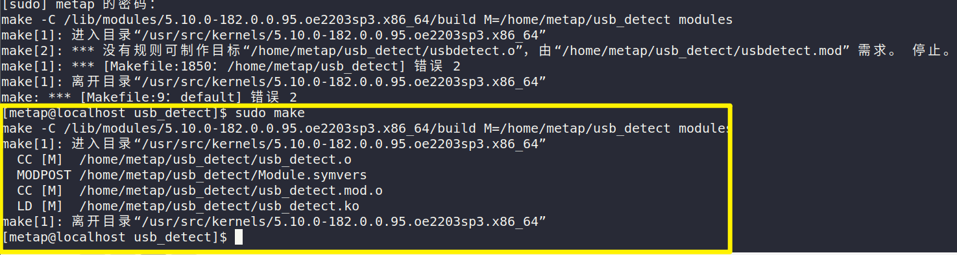
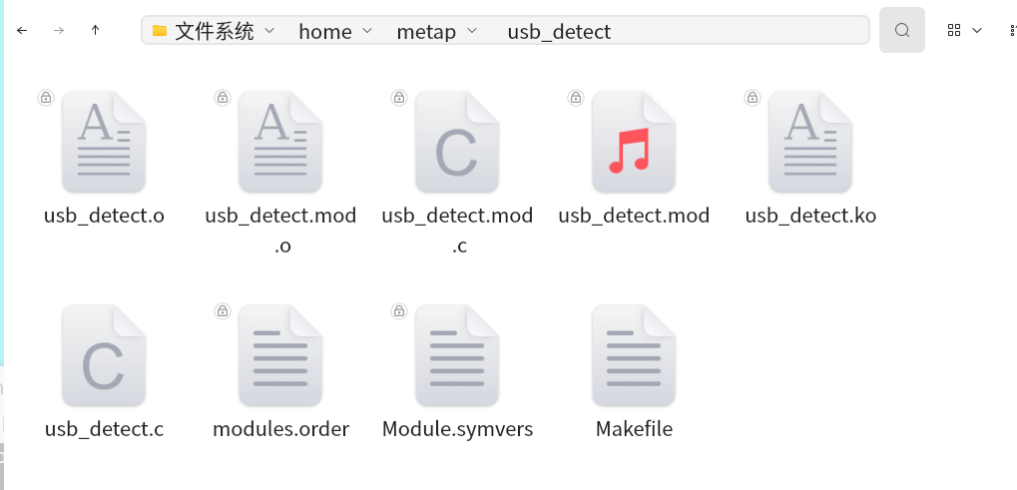
卸载自带的模块
sudo rmmod uas
sudo rmmod usb_storage
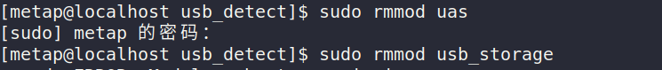
加载新创建的模块
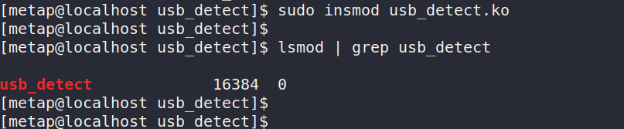
查看加载的内容——dmesg
U盘插入检测结果：
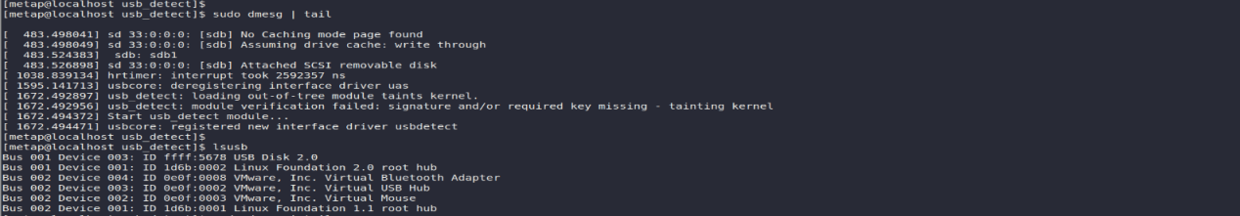
拔出U盘后
sudo dmesg | tail
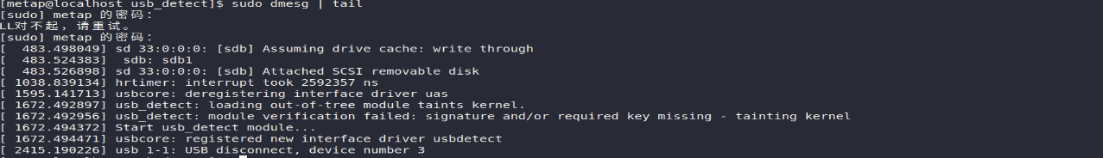
lsusb
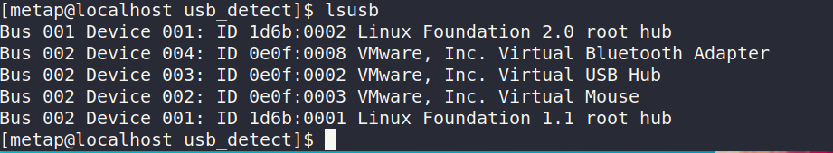
卸载模块
sudo dmesg | tail

任务二：
read_speed_test.c文件源码：
#include <linux/module.h>
#include <linux/kernel.h>
#include <linux/fs.h>
#include <linux/buffer_head.h>
#include <linux/slab.h>
#include <linux/time.h>

#define MY_BLOCK_SIZE 4096 // 自定义块大小

static int __init read_speed_init(void) {
struct file *file;
char *buffer;
loff_t pos = 0;
size_t bytes_read;
struct timespec64 start, end;
unsigned long long duration;
int i;

buffer = kmalloc(MY_BLOCK_SIZE, GFP_KERNEL);
if (!buffer) {
printk(KERN_ERR "Failed to allocate memory\n");
return -ENOMEM;
}

file = filp_open("/dev/sda", O_RDONLY, 0);
if (IS_ERR(file)) {
printk(KERN_ERR "Failed to open device\n");
kfree(buffer);
return PTR_ERR(file);
}

ktime_get_real_ts64(&start);

for (i = 0; i < 1024; i++) { // 读取 1024 个块
bytes_read = kernel_read(file, buffer, MY_BLOCK_SIZE, &pos);
if (bytes_read < 0) {
printk(KERN_ERR "Failed to read from device\n");
filp_close(file, NULL);
kfree(buffer);
return bytes_read;
}
}

ktime_get_real_ts64(&end);

duration = (end.tv_sec - start.tv_sec) * 1000000000ULL + (end.tv_nsec - start.tv_nsec);
printk(KERN_INFO "Read speed: %llu MB/s\n", (1024ULL * MY_BLOCK_SIZE * 1000000000ULL) / (duration * 1024ULL * 1024ULL));

filp_close(file, NULL);
kfree(buffer);

return 0;
}

static void __exit read_speed_exit(void) {
printk(KERN_INFO "Read speed test module unloaded\n");
}

module_init(read_speed_init);
module_exit(read_speed_exit);

MODULE_LICENSE("GPL");
MODULE_AUTHOR("Author");
MODULE_DESCRIPTION("A module to test read speed");

Makefile文件
obj-m += read_speed_test.o

all:
make -C /lib/modules/$(shell uname -r)/build M=$(PWD) modules

clean:
make -C /lib/modules/$(shell uname -r)/build M=$(PWD) clean

write_speed_test.c文件源码：
#include <linux/module.h>
#include <linux/kernel.h>
#include <linux/fs.h>
#include <linux/buffer_head.h>
#include <linux/slab.h>
#include <linux/time.h>

#define MY_BLOCK_SIZE 4096

static int __init write_speed_init(void) {
struct file *file;
char *buffer;
loff_t pos = 0;
size_t bytes_written;
struct timespec64 start, end;
unsigned long long duration;
int i;

buffer = kmalloc(MY_BLOCK_SIZE, GFP_KERNEL);
if (!buffer) {
printk(KERN_ERR "Failed to allocate memory\n");
return -ENOMEM;
}

memset(buffer, 0, MY_BLOCK_SIZE);

file = filp_open("/dev/sda", O_WRONLY, 0);
if (IS_ERR(file)) {
printk(KERN_ERR "Failed to open device\n");
kfree(buffer);
return PTR_ERR(file);
}

ktime_get_real_ts64(&start);

for (i = 0; i < 1024; i++) {
bytes_written = kernel_write(file, buffer, MY_BLOCK_SIZE, &pos);
if (bytes_written < 0) {
printk(KERN_ERR "Failed to write to device\n");
filp_close(file, NULL);
kfree(buffer);
return bytes_written;
}
}

ktime_get_real_ts64(&end);

duration = (end.tv_sec - start.tv_sec) * 1000000000ULL + (end.tv_nsec - start.tv_nsec);
printk(KERN_INFO "Write speed: %llu MB/s\n", (1024ULL * MY_BLOCK_SIZE * 1000000000ULL) / (duration * 1024ULL * 1024ULL));

filp_close(file, NULL);
kfree(buffer);

return 0;
}

static void __exit write_speed_exit(void) {
printk(KERN_INFO "Write speed test module unloaded\n");
}

module_init(write_speed_init);
module_exit(write_speed_exit);

MODULE_LICENSE("GPL");
MODULE_AUTHOR("Author");
MODULE_DESCRIPTION("A module to test write speed");

Makefile文件
obj-m := write_speed_test.o

KDIR := /lib/modules/$(shell uname -r)/build
PWD := $(shell pwd)

all:
$(MAKE) -C $(KDIR) M=$(PWD) modules

clean:
$(MAKE) -C $(KDIR) M=$(PWD) clean
操作步骤与结果：
read_speed_test装载：
sudo make 编译
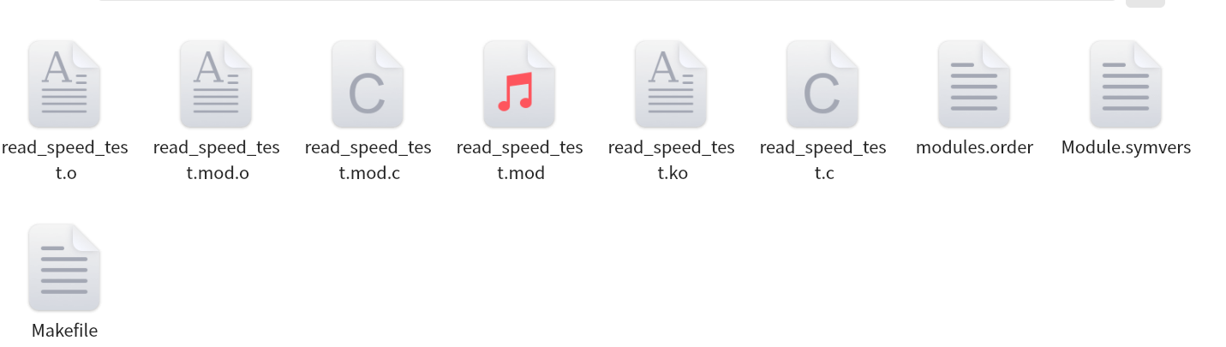
sudo insmod read_speed_test.ko装载
sudo dmesg | grep 查看日志
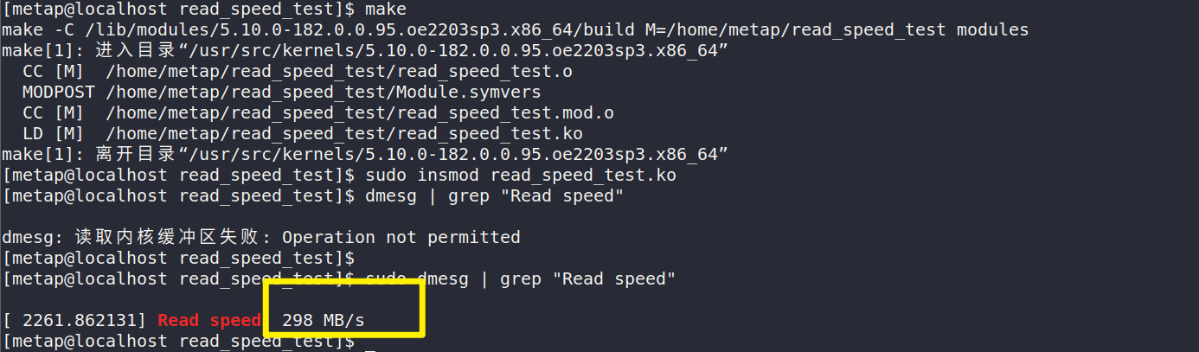
sudo rmmod read_speed_test
卸载模块
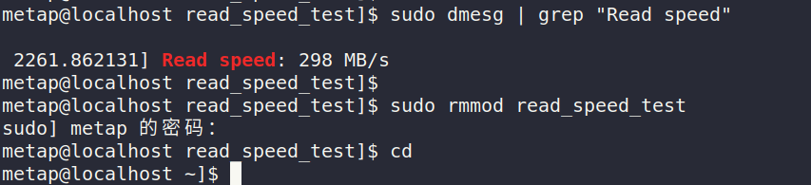
write_speed_test装载：
sudo make编译
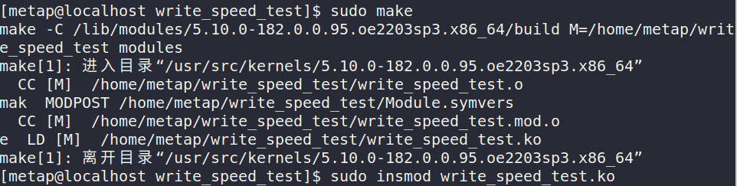
write_speed_test装载
sudo insmod write_speed_test.ko
查看日志
dmesg | grep "Write speed"
卸载

# 下载和解压 iozone
wget http://www.iozone.org/src/current/iozone3_489.tar
tar -xvf iozone3_489.tar
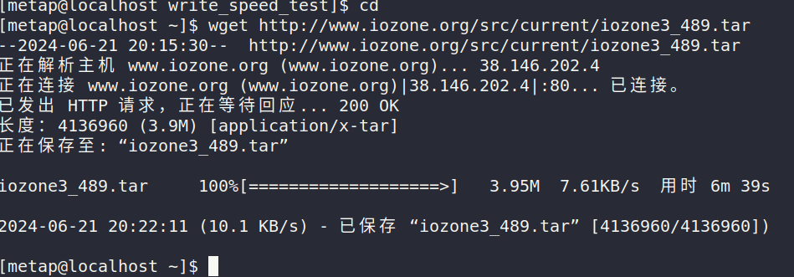
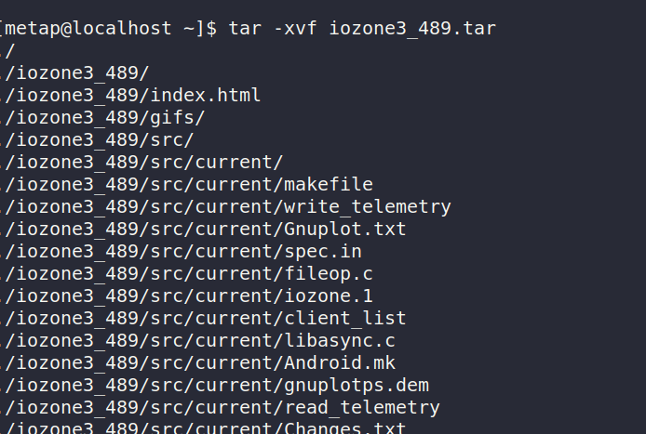
cd iozone3_489/src/current
# 编译 iozone 工具
make linux
free -m
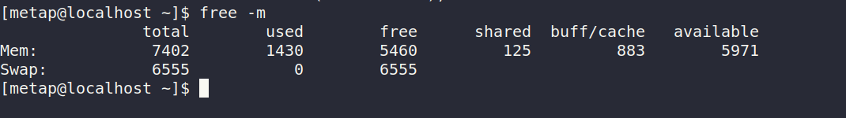
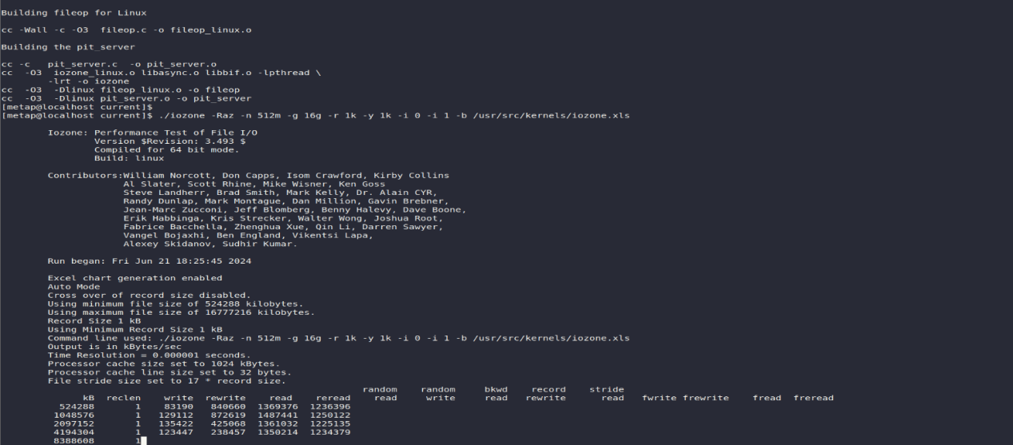
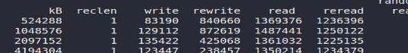
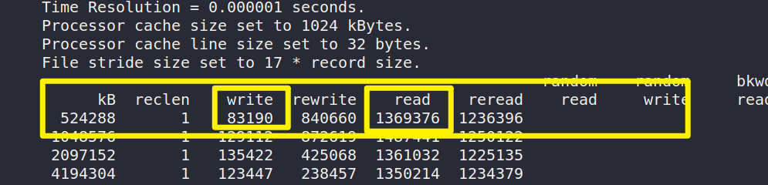
由最后一张图数据可知:
对于内核模块程序中，写入的文件大小是512M，读取的文件是之前写入的大小为512M的文件；且读写的记录块都是1024byte；对应于图中的数据，iozone测试的文件大小为512M、记录块为1024byte的写速率是 83190kb/s（即81.24M/s），读速率是 1369376kb/s（即1337.28M/s）。
比较和分析
iozone 测试结果与模块测试结果存在较大差异，这可能由以下几个原因导致：
IO方式不同：iozone 可能使用了更高级的IO方式，如直接IO（Direct IO）或者异步IO，这些方式可以绕过操作系统的缓存和同步IO的开销，从而获得更高的性能。
缓存策略：操作系统和文件系统的缓存策略可能不同，iozone 测试可能会优化缓存管理以提升IO性能。
测试环境：iozone 可能在测试中使用了更多的优化策略和并发操作，而我的模块测试可能仅限于简单的顺序读写操作。
- 实验分析
任务一
在进行USB Detect驱动程序的修改过程中，通过添加和调整代码，成功实现了对特定USB设备的识别和驱动加载。通过这个实验，我学会了如何利用Linux内核编程接口编写USB驱动程序，理解了驱动注册、设备探测和断开处理的过程。这不仅加深了对Linux内核编程的理解，还提升了对USB子系统的认识和应用能力。
任务二
通过本次实验，学到了如何利用Linux内核模块进行磁盘读写速度测试，并且了解到不同工具（如iozone）对性能测试的不同方法和计量标准。实验过程中遇到的挑战包括内核版本和依赖项的管理，以及测试结果与预期之间的差异分析。这些经验增强了对Linux内核IO操作和性能优化的理解，为未来系统调优提供了宝贵的经验和方法。

五、所遇问题及解决方法
1.编译出错，检查后是Makefile文件出错，更改后编译成功

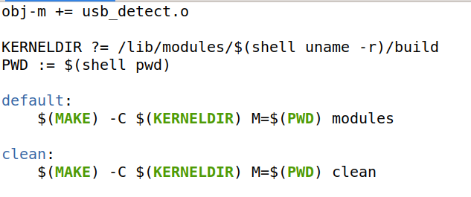

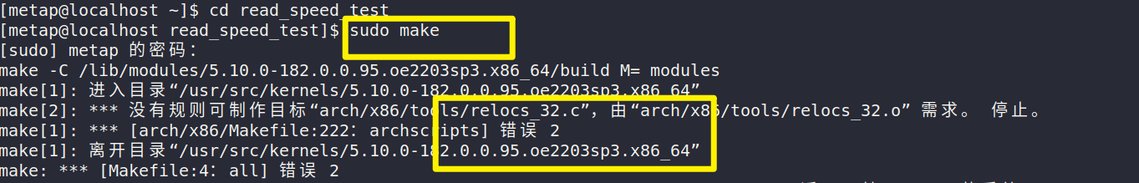2.编译失败
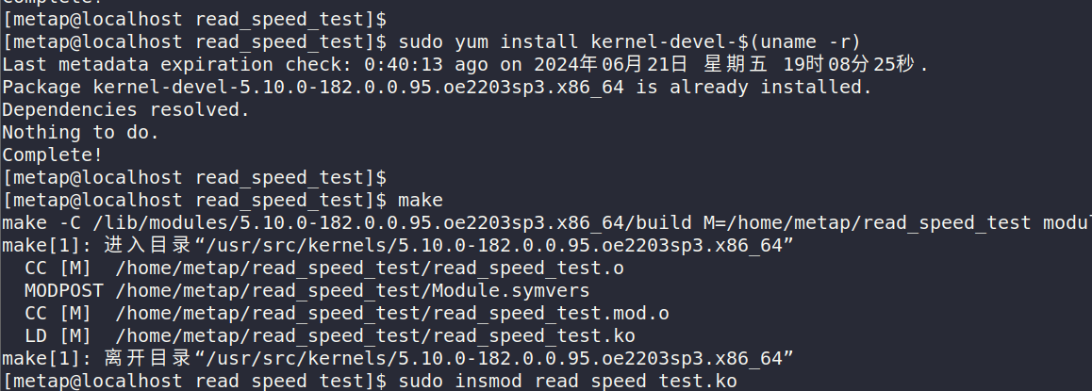
sudo yum install kernel-devel-$(uname -r)
安装工具包后成功

